Medine Sahin

Dr. Foley & Dr. Snyder

How Cool is That

1. **Question 1: In what spectral region does Planck’s Blackbody Law peak at 300 K? How does this compare to the peak of the solar spectrum?**

* The Planck’s Blackbody curve represents the distribution of the intensity of radiation that was emitted by any heated object. Blackbody is a type of object where the emissive property is directly (closely) related to the temperature. The light that is produced by Blackbody is continuous and its relationship with temperature as shown, in the figure below, the x-axis represents the wavelength of the light emitted in nanometers, the y-axis represents the intensity as the temperature increases and the emitted light changes. This shift is due to temperature is known as the Wien’s law. Wien’s displacement law states that the product of the maximum wavelength for the emission times the temperature equals to the Wien’s displacement constant.
* λ*max* = *b/T*
* b is the Wien’s displacement constant (2.8977685 x 10^-3 ) meter/K and T is temperature in Kelvin (K), λ*max*  is the energy wavelength
* So when the peak is at 300 K, the spectral region is ;

λ*max* = (2.8977685X10^-3M-K)/ (300k) = 9.67X10^-6 meters which is equivalent to 9.67 micrometers. That is in the visible spectroscopy comparing to the peak of the solar spectrum (shown in figure 2)

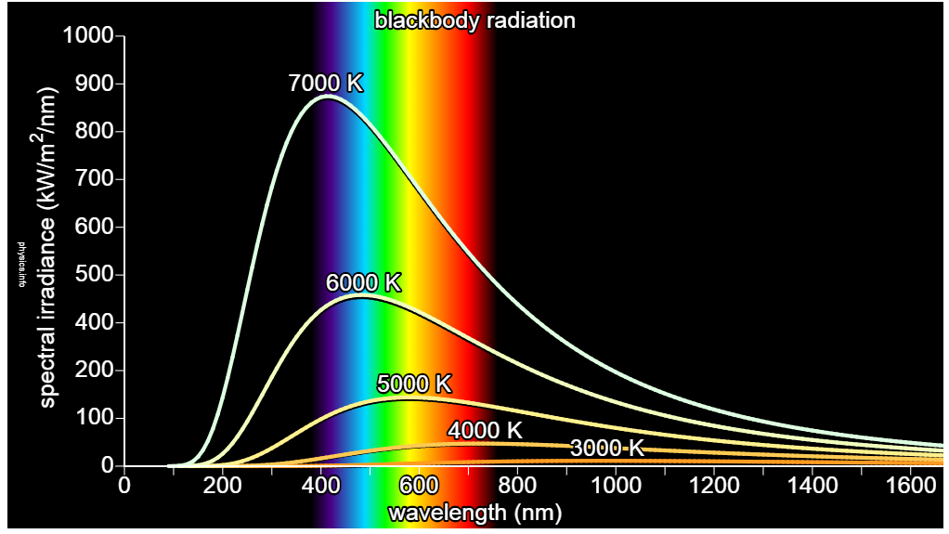

(Retrieved from <https://physics.info/planck/>)

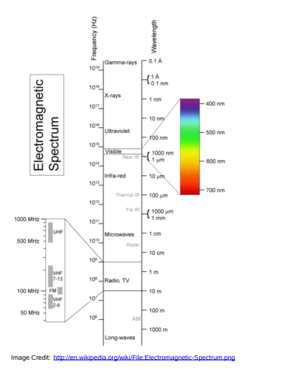

1. **Question 2: What properties do you think an ideal cooling material should have in terms of its emissivity/absorptivity in the spectral region that overlaps with the solar spectrum?**

* The material needs to radiate more energy into the universe than it absorbs from the universe. Thermal radiation is a value which can lower the operating temperature of the range without any energy input. Emissivity is represents the ratio of the radiation that was emitted by the surface at a given temperature, and it is denoted by E. This value varies between 0 ≤ E ≥ 1. It measures the closeness of the surface to blackbody and for an ideal blackbody emitter, E =1 for all angles & wavelengths. Absorptivity is known as the fraction of the absorb energy by the surface (1). In this case, we would need to make E closer or equal to 0 to obtain a better reflection because the absorptivity/emissivity of an opaque material is complementary to its reflectance: *E* (*λ*) = 1 − *R* (*λ*). If we were to obtain more reflection it absorbs higher energy and if it was light reflection absorbs then it is less energy.

1. **Question 3: What properties do you think an ideal cooling material should have in terms of its emissivity/absorptivity in the spectral region that overlaps with the Blackbody spectrum at 300 K?**

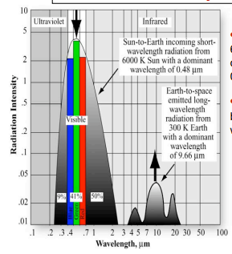 Image retrieved from <https://topex.ucsd.edu/rs/Lec06.pdf>

* When the Blackbody spectrum is at 300 K, we would see a wavelength around 9.66 micrometer. At this temperature, the atmosphere is more open therefore more absorption will be obtain by the atmosphere.

1. **Question 4: How can you explain the origin of the radiation flowing from the earth’s atmosphere to the structure? Why does the sky itself radiate?**

* When Earth try to balance the both extreme of hotness and coldness, it does it in four different ways such as through conduction, convection, latent heat and radiation. Radiation is known as the final process of this heat transfer between both extreme weather conditions. The energy that is coming from Sun has different wavelengths. Wavelength is the distance from one peak to another peak. The shorter the wavelength, the higher the energy required. Every single object that absorbs radiation from the sun give back a weaker form of energy known as radiation. The Earth itself radiates the energy absorbed from the Sun in the form of radiation. (2) The light waves hit the Earth and this allow Earth to balance the heat transfer to move the energy around.

Reference List

1. <https://web.ics.purdue.edu/~pbermel/pdf/Sun17a.pdf>
2. <https://www.opengeography.org/ch-3-earths-atmosphere.html>